### Abstract Expressionism in Japan, (抽象表現主義, chūshō hyōgenshugi)

Abstract Expressionism emerged in Japan in 1954 at the end of the American Occupation, and only nine years after Hiroshima and Nagasaki, when a group of seventeen artists living in Osaka founded the *Gutai* (具体, embodiment) artists association. More than any other group in Japan, the *Gutai* artists considered and engaged with Abstract Expressionism, particularly the works of Jackson Pollock. Arguably one of the most successful Japanese disciples of American Abstract Expressionism was Okada Kenzō, who migrated to the United States in the 1950s and made a name for himself by using the decorative effects of traditional Japanese paintings in his works. Just as the Japanese artistic Diaspora had infused Abstract Expressionism with their alterity in New York, American Expressionism made appearances in Japan through *Gutai* artists, whose derivative Abstract-Expressionistic paintings constituted the rebellions of a **younger generation of artists against a society responsible for the destruction that occurred during the war**. The post-war Japanese assimilation of Western institutions and values is often described as a knee-jerk reaction against Japanese militarism and a means of expressing the freedom of the newly embraced democratic reforms.

An international offshoot of the American post-World War II graphic art movement, Japanese Abstract Expressionism developed into a globally pervasive force throughout the 1950s. During the 1950s a large vanguard of Japanese artists relocated to the United States, including Hasegawa Saburō (長谷川三郎), Inokuma Gen’ichirō (猪熊弦一郎), Kawabata Minoru (川端実), Masatoyo Kishi (政豊岸), Niizuma Minoru (新妻実), Okada Kenzō (岡田謙三), Teiji Takai (伊藤ていじ), and James Hiroshi Suzuki.

Abstract Expressionism has been identified as a politically motivated articulation of American identity in the Post-World War II world. In this sense the radical native *Gutai* and Japanese influence on Abstract Expressionism in the United States was regarded as evidence of the imperialistic success of the American way in the Asia-Pacific region. Despite the fact that Asian and in particular Japanese influences on Abstract Expressionism were tenuous, the internalisation of ‘oriental thought’ and especially Zen was an important ingredient in juxtaposing nationalistic American aesthetic trends in opposition to European art, after the successful defeat of Japan in the Asia-Pacific theatre.

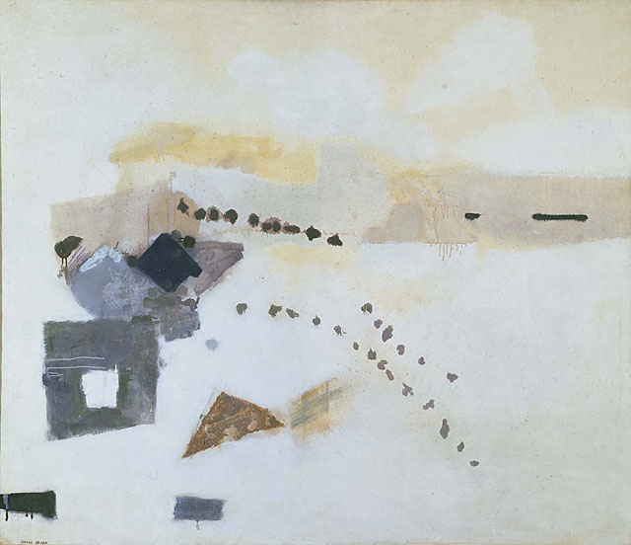

Kenzō Okada, *Footsteps*, 1954, oil on canvas, 153x177.5 cm, The Phillips Collection, Washington.

**References and further reading:**

Marter, M. Joan ed. (2007) *Abstract Expressionism: The International Context*. New Brunswick, N.J.: Rutgers University Press.

Tiampo, Ming. (2011) *Gutai: Decentering modernism*. Chicago; London: The University of Chicago Press.

Kenzō, Okada. (November 22, 1968) ‘Oral history interview with Kenzo Okada,’ in Archives of American Art. . Online at: < http://www.aaa.si.edu/collections/interviews/oral-history-interview-kenzo-okada-12022>. Accessed: 16 September 2013.

Winther-Tamaki, Bert. (2001) *Art in the Encounter of Nations: Japanese and American artists in the early post-war years*. Honolulu: University of Hawai'i Press.